

# **SQL PROJECT**

**World Wide Energy Consumption**

Yellow Students,

This data was taken from an eia organization that tracks energy consumption,emissions, production, population etc for different countries.

I hope you enjoy the observations you make as they will reflect reality and help you understand the correlation between economical power ,consumption and emission.

### Understanding Your Data Files:

### **🌍 Database Context**

You are working with a structured energy dataset comprising 6 CSV files that have been imported into a MySQL database named energy. These tables include [**Dataset**:](https://drive.google.com/drive/folders/1OYOxCWV4rhQZrNwyQ-BXy6T_Wb-9cAfc)

* **country** (central table)
* **consumption**
* **production**
* **emission**
* **gdp_ppp**
* **population**

Each of the tables (except country) has a foreign key referencing the country table's country column.

### **Schema Summary**

**1.** ER Diagram

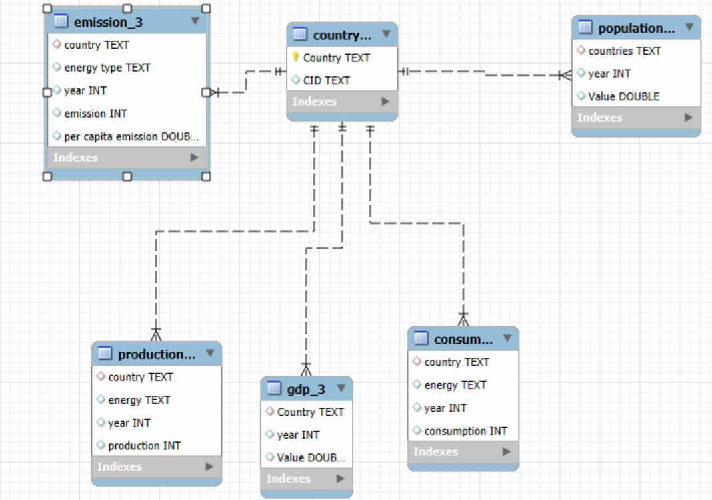

**SQL query to create tables**

| CREATE DATABASE ENERGYDB2;  USE ENERGYDB2;  -- 1. country table  CREATE TABLE country (  CID VARCHAR(10) PRIMARY KEY,  Country VARCHAR(100) UNIQUE  );  SELECT * FROM COUNTRY;  -- 2. emission_3 table  CREATE TABLE emission_3 (  country VARCHAR(100),  energy_type VARCHAR(50),  year INT,  emission INT,  per_capita_emission DOUBLE,  FOREIGN KEY (country) REFERENCES country(Country)  );  SELECT * FROM EMISSION_3;  -- 3. population table  CREATE TABLE population (  countries VARCHAR(100),  year INT,  Value DOUBLE,  FOREIGN KEY (countries) REFERENCES country(Country)  );  SELECT * FROM POPULATION;  -- 4. production table  CREATE TABLE production (  country VARCHAR(100),  energy VARCHAR(50),  year INT,  production INT,  FOREIGN KEY (country) REFERENCES country(Country)  );  SELECT * FROM PRODUCTION;  -- 5. gdp_3 table  CREATE TABLE gdp_3 (  Country VARCHAR(100),  year INT,  Value DOUBLE,  FOREIGN KEY (Country) REFERENCES country(Country)  );  SELECT * FROM GDP_3;  -- 6. consumption table  CREATE TABLE consumption (  country VARCHAR(100),  energy VARCHAR(50),  year INT,  consumption INT,  FOREIGN KEY (country) REFERENCES country(Country)  );  SELECT * FROM CONSUMPTION; |
| --- |

**Procedure to work with the files:**

1. Create a database

2. In the navigator section select the created database and right click on it

3. Select “**Table Data Import Wizard**” and get the csv file one by one from the dataset provided(kindly first download the csv file in your systems from the drive link provided).

4. Once data is imported , use alter to create relationships between tables

Note: check the er-diagraam to create relationships between the tables

Refer the below:

**country (1) → (many) emission_3**

**country (1) → (many) population**

**country (1) → (many) production**

**country (1) → (many) consumption**

**country (1) → (many) gdp_3**

## **Data Analysis Questions**

**General & Comparative Analysis**

**What is the total emission per country for the most recent year available?**

**What are the top 5 countries by GDP in the most recent year?**

**Compare energy production and consumption by country and year.**

**Which energy types contribute most to emissions across all countries?**

**Trend Analysis Over Time**

**How have global emissions changed year over year?**

**What is the trend in GDP for each country over the given years?**

**How has population growth affected total emissions in each country?**

**Has energy consumption increased or decreased over the years for major economies?**

**What is the average yearly change in emissions per capita for each country?**

**Ratio & Per Capita Analysis**

**What is the emission-to-GDP ratio for each country by year?**

**What is the energy consumption per capita for each country over the last decade?**

**How does energy production per capita vary across countries?**

**Which countries have the highest energy consumption relative to GDP?**

**What is the correlation between GDP growth and energy production growth?**

**Global Comparisons**

**What are the top 10 countries by population and how do their emissions compare?**

**Which countries have improved (reduced) their per capita emissions the most over the last decade?**

**What is the global share (%) of emissions by country?**

**What is the global average GDP, emission, and population by year?**

**Challenges:**

* The project demands you to develop a perspective of your own,
* You will find that many questions have different ways to be solved,
* Your job is to have a reasoning behind why you have chosen to solve the question in that particular way.

## **Project Presentation Template**

As part of this project, you are required to create and present the analysis findings. Use the following PowerPoint template to structure your presentation:

**👉Click here to**  [**find the PPT Template for the Project Presentation**](https://docs.google.com/presentation/d/1FRAhxJvT_DtNSW7G4Ylg2H8EXofedkfj/edit?usp=sharing&ouid=100278407567332116222&rtpof=true&sd=true)

## **Submission**

After completion of the project, Zip the **.sql query file** and **PPT** upload the zip file with your name and batch number. In LMS.